Secure Password Management Systems: A Comprehensive Analysis of RSA Encryption versus Traditional Hashing Methods with Experimental Evaluation
Tarak Hussain ^{1*}, Kommireddy Pavan Kumar Reddy², Dokuparthi Kundan ³, Kotipalli Praveen Kumar ⁴, Gunti Meghana⁵
^{1,2,3,4,5} Department of Computer Science and Engineering
Koneru Lakshmaiah Education Foundation
Vaddeswaram, Guntur 522302, India
tariqsheakh2000@gmail.com
Abstract
The research shows exploration to store passwords securely using both RSA encryption and various modern cryptographic hashing algorithms. We built Spring Boot applications to measure the performance, security and scalability of both technologies using benchmarks and tests. While RSA encryption is significantly faster than any hashing method (by 2.3 to 3.1 times) during initial storage, RSA has several critical security weaknesses, including its reversible nature and the fact that it has a central point of failure. In comparison, modern hashing methods (bcrypt, Argon2, scrypt) have many stronger security features than RSA encryption due to their one-way transformations, built-in salting mechanisms, and tunable work factors that continue to become faster with advances in computing power. Load testing and simulated attacks against enterprise password management systems with up to 10,000 concurrent users provide a quantitative measure of how much security is gained or lost compared with being able to store passwords using one of the aforementioned technologies. In addition, our results and recommendations are in line with both NIST SP 800-63B and OWASP guidelines, but also provide a new and improved understanding of the operational aspects of using different cryptographic technologies in production environments.
Index Terms: Password security, RSA encryption, password hashing, bcrypt, Argon2, Spring Boot, cryptography, key management, enterprise security, authentication, experimental evaluation, performance benchmarking
I. INTRODUCTION
A. Research Objectives
Research Questions
The objectives of the research are to systematically assess the differences between current best practices for the Hashing of Passwords and the conventional practice of using RSA Encryption to Secure Passwords. To do so, the following specific questions will be addressed in the course of the research:
1. RQ1: Cryptographic Security Properties: What is the difference in security between RSA Password Encryption and current best practices for Password Hashing (such as BCRYPT/SCRYPT/ARGON2) with respect to resistance to offline attacks, preservation of entropy, and susceptibility to precomputation?
2. RQ2: Performance, Scalability, and Resource Efficiency: Under realistic authentication workloads and concurrent access patterns, how do the performance (latency and throughput), resource utilization (CPU and Memory), and efficiency of using RSA Password Encryption compare to Memory-Hard Hashing Techniques?
3. RQ3: Enterprise Key Management and Operational Risk: What are the implications (both practical and architectural, as well as security) of managing the life cycle of Cryptographic Keys (Key Creation, Distribution, Storage, Access Control, Rotation, and Recovery) using RSA in an enterprise environment for the purpose of Password Storage?
4. RQ4: Resistance to Practical Attack Models: How does the use of RSA Encryption for Passwords and Hashing of Passwords compare with respect to the Attacker's Costs, Time-to-Compromise, and Success Probability under the simulated environment of several common Attack Vectors (Brute Force Enumeration, Dictionary Guessing, and Rainbow Table Precomputation)?
In addition, data will be collected to compare to determine the difference between Victims and Attackers' point of view based on the costs associated with both vantage points.

B.Contributions
The research establishes the following novel and technical contributions:
A systematic experimental evaluation directly compared password encryption using RSA technique to that of the more recently developed password hashing techniques. This evaluation provides precise quantitative metrics regarding both execution time, throughput and system level resource consumption.
An attack-centric type of security evaluation was conducted which utilized simulations to model an offline adversary and demonstrate, through empirical evidence, the differing abilities of using a password encryption or a password hashing technique to resist brute force, dictionary and rainbow table attacks.
An enterprise-scale load and scaling evaluation was taken by systematically testing the scalability of RSA password encryption and password hashing during concurrent authentication loads supporting up to 10,000 concurrent authentication requests. Testing captured the degradation of performance patterns, contention effects and limits of practical throughput.
A key management cost-risk assessment for RSA encrypted passwords was conducted which provided a detailed cost-benefit and risk analysis of the operational complexity, modes of failure and limits of security exposure associated with each of these two password management infrastructures.
Finally, a guideline to identifying and developing production-ready implementations for securely storing passwords in Spring Boot enterprise applications was created. This production ready implementation guideline linked theoretical principles of secure software practices to real-world engineering considerations.
C.Empirical Validation of Security Standards
Comprehensive validations should be made and recorded for the NIST SP 800-63B and OWASP Authentication Cheat Sheet recommendations proving that the data based on these empirical validations supports the practice of contemporary best practices as compared to using older ways to encrypt credentials.

II. BACKGROUND AND FUNDAMENTALS
A. Password Storage Security Requirements
Effective password storage systems must simultaneously satisfy multiple, often competing, security and operational requirements. Unlike general data protection, password storage must assume eventual system compromise and therefore focus on minimizing post-breach damage rather than preventing breaches entirely [1], [2].
1) Confidentiality Under Breach (Breach Resistance):
The main goal for storing passwords securely is that, in the event an attacker compromised an authentication database, the attacker would not immediately gain access to all the user's plaintext passwords. This quality, often referred to as breach resistance, implies that an attacker gaining full access to the credential storage will not be able to use this information to effectively attack the user's account [1]. Industry studies have demonstrated that if the password storage does not implement this requirement, the percentage of users who will experience a second set of credential theft due to the password(s) used being reused at other websites is extremely high.
In addition to safeguarding users' credentials from attacks on the credential storage, secure password storage mechanisms must also be designed to protect the user's credentials from various forms of offline attacks (i.e., when the user's credentials are compromised). Some common forms of offline attacks include:
- Bruce Force Attacks – where an attacker attempts every possible password combination within the user's password space.
- Dictionary Attacks – an attacker uses a list of common passwords that have been compiled from previous data breaches.
- Rainbow Table Attacks – an attacker exploits a precomputed relationship between the hash of a password and the password used to generate that hash.
- Credential Stuffing – the attacker accumulates thousands of compromised accounts, which may or may not relate to each other, and then attempts to log into accounts using the same credentials.
- Parallel processing attacks – the attacker uses graphical processing units (GPUs) or application-specific integrated circuits (ASICs) to expedite the password guess process.
Research on how people choose their passwords shows that they often choose weak, predictable, or reused passwords, increasing the effectiveness of attacks when combined with inadequate storage systems[9][11].
The standard for password authentication balancing security and usability is authentication operations typically should complete between 100 and 500 ms to provide an acceptable user experience, yet have enough computational cost associated with them to prevent massive guessing attacks[2][4].
Too much latency will decrease system responsiveness; however, low computational costs prevent attacks from being difficult.
Enterprise-level authentication systems must have workload models that scale linearly as the user population increases, and as the number of requests for authentication processes increases. Therefore, password storage systems must maintain their security effectiveness when in parallel use by many users, without requiring a redesign of the underlying architecture or specialized hardware[3].
New implementations must follow existing industry standards and regulatory regulations, including NIST SP 800-63B and OWASP Password Storage Guidelines. All of these regulatory frameworks call for strong protection of credentials, and protecting personal information in the event of a breach, such as GDPR, HIPAA and PCI-DSS[1][2]

B. Cryptographic Foundations
1) RSA Encryption
RSA (Rivest–Shamir–Adleman) is an asymmetric public-key cryptosystem whose security is based on the computational difficulty of factoring large composite integers [5]. Let
$n=pq$, where $p$and $q$are large prime numbers. The RSA operations are defined as:
Encryption:
$C≡M^{e}(modn)$ ---eq. 1
Decryption:
$$M≡C^{d}\left(modn\right)--------eq.2$$
Cryptographic engineering literature points out that RSA's structures render it ineffective for password storage. When the private RSA key is held by the attacker, he may obtain all of the associated encrypted password based on NSA's clear crypto system design—reversal of an RSA encryption allows for easy decryption resulting in immediate credential exposure and catastrophic credential disclosure. All that is being discussed is that the inability to maintain proper control of a private RSA key is not a "weakness" of RSA but rather a design flaw within the structures utilized for authentication systems [13].

2) Cryptographic Hash Functions for Password Storage
To create a hash from a password, generating h(x) is a very simple operation, whereas determining x from h(x) cannot be performed with reasonable computational effort. Today's password hashing schemes build upon fundamental hashing techniques and add supplementary layers of defensive measures to protect against offline attacks [2],[4].
Salting:
Each password is combined with a unique, randomly generated salt prior to hashing:
$$\text{stored_hash}=\text{hash}(\text{password}∥\text{salt})$$
Salting ensures that identical passwords produce different hash values, effectively neutralizing precomputed rainbow table attacks [2], [7].
Key Stretching (Adaptive Work Factor):
To increase the computational cost of password guessing, hashing functions iteratively apply the hash operation:
$$h_{0}=\text{hash}(\text{password}∥\text{salt}) \\ h_{i}=\text{hash}(h_{i-1}),i=1,…,k \\ \text{stored_hash}=h_{k}$$
To provide a balance between security and ease of use, the number k (the iteration count also called work factor) can be adjusted for performance and security purposes; adaptive algorithms such as bcrypt have the ability to reduce the work factor to accommodate changes in hardware performance, including improved CPU/Microprocessor technologies ([4]).
Memory Hardness: The leading password hashing methods, scrypt and Argon2, are both memory intensive. Due to their memory requirements, they greatly diminish the efficiency of the growing use of massively parallel computing technology to attack hashed passwords through GPUs, FPGAs, and ASICs. With the memory capacity and bandwidth becoming the dominant factors in the limitation of how fast passwords can be attacked compared to other methods ([6]) and ([7]) the end result is that on most common computing devices the latter technology will most likely be used to attack a hashed password rather than be able to attack the method of quickly finding a hashed password using an invented technology ([6]) or ([7]).
The combined properties of salting, key stretching, and memory hardness differentiate bcrypt, scrypt, and Argon2 from traditional cryptography; these are all designed specifically for the secure storage of credentials, therefore making them superior to traditional symmetric encryption methods such as RSA for protecting credentials from unauthorized access during a data breach ([1]), ([2]), ([6]).
VII. RELATED WORK AND LITERATURE REVIEW
A. Industry Standards and Guidelines
According to NIST SP 800-63B, the Digital Identity Guidelines provide authoritative best practices for digital authentication systems and specifically state that credentials must be stored using one-way password hashing methods[1]. In addition, NIST suggests against using reversible encryption methodologies when storing passwords or any other credential information, as explained in reference 1. In order to prevent offline brute-force password attacks against stored passwords, password storage functions should utilize both salting and adaptive costing techniques to reduce the damage caused by large-scale credential losses resulting from data breaches. This paper provides experimental data that supports these recommendations through the demonstration of significant differences in attack resistance, computational costs, and impacts of breaches between hashing and reversible encryption techniques.
Likewise, from the guidance given within the OWASP Password Storage Cheat Sheet it is apparent that the recommended best practices to properly store your passwords in production systems, which would be accomplished with the use of modern and secure password hashing algorithms that are adaptive and memory-hard in nature (*bcrypt, *scrypt and *Argon2, in addition to salting and parameter configurations) exist.
OWASP is focused specifically on providing this guidance to developers with practical advice for their common application development platforms[2].
The results of our integration study done using Spring Boot, confirmed both the validity of these OWASP recommendations, as well as the practical use of the Spring Security reference architecture in implementing the methods outlined to create secure password storage solutions that are easy to use and that provide significant increases to the security of credentials[3]. This puts OWASP in a strong position to demonstrate that development of a password storage solution that meets enterprise-sized password security requirements can be accomplished using existing tools and technologies by the average developer.
B. Academic Research
The initial research conducted by Provos and Mazières produced bcrypt, which is a password hashing method that can adaptively adapt to faster processors[4]. The design of bcrypt therefore provided a fundamental premise on which many modern password storage systems are based, namely the ability to increase the amount of processing capacity that is required to retrieve stored credentials without the need to change the way that the credentials are stored.
Our evaluation of how effective bcrypt is today has demonstrated that the selection of an appropriate work factor can compensate for many of the performance advantages that are currently available to CPUs while still maintaining an acceptable latency associated with authenticating users[6].
Biryukov and coworkers then went on to build upon the adaptive hashing schemes that were already in use, with Argon2, which was selected as the winner of the PHC, having been designed to meet very specific criteria with regard to how resistant it is to GPU or ASIC-accelerated attacks as well as being configurable in terms of the durability of its memory resources, configuration time, and configuration using multiple CPUs.
As such, Argon2 is viewed as a significant advancement in password hashing technology, as shifted much of the cost associated with conducting brute force attacks on passwords, which were previously based on raw computing, to costs associated with memory bandwidth and capacity today. Simulation of possible attacks conducted on Argon2s have confirmed that Argon2 is much more resistant to GPU or ASIC-based attacks than previously proposed password hashing algorithms.
The first memory hard hashing functions available to the masses was scrypt. Developed by Percival, scrypt helped[7] to mitigate the economics of a large scale brute force attack by adding a large memory footprint (in the gigabytes) per guess for each password attempt. Our research has shown that scrypt provides strong security assurances as compared to bcrypt but has a greater cost associated with both memory and processing. These findings support the previous empirical studies of password hashing algorithms and provide additional evidence for the position of scrypt as a viable high-security solution for organizations that will deal with attacks from well-resourced attackers.
C. Cryptographic Engineering Perspectives
The cryptographic engineering literature supports a common view that reversible encryption is an inherently inadequate method for storing passwords. This view is predicated upon the belief that all systems will eventually experience a compromise; thus, the means of securing the system should focus on limiting harm rather than on concealing the contents of such systems from unauthorised users. The vulnerabilities identified by Schneier within his study of vulnerability analysis for products using different types of cryptography show us that when key exposure leads to catastrophic failures of design mechanisms, those mechanisms represent weaknesses in the structure of product design, not a failure in implementation [12].
Therefore, systems created for user verification of passwords must depend on computationally burdensome, one-way functions, instead of relying upon reversible representations. While these types of discussions are generally given at the higher level of theory or concepts and in the form of general architectural discussions, this work provides a quantitative validation through direct experimentation of these principles at the operational level. Through a side-by-side comparison of credential and recovery rates, and computational costs for a number of known breach scenarios, this study provides a direct connection between theory and practice in both cryptography and user verification methods as they are used in practice by the security industry [1] and in their practical applications [2].

III. EXPERIMENTAL METHODOLOGY
All experiments were conducted on a repeatable and controlled environment consisting of an Intel Xeon E5-2680 v4 processor (14 cores at 2.4 GHz), 64 GB DDR4-2400 RAM, a 1 TB Samsung 970 EVO Plus NVMe SSD, and a 10 Gbps Ethernet connection. The environment was set up with Ubuntu 22.04 LTS (Linux Kernel 5.15) as the operating system, OpenJDK 17.0.8, Spring Boot 3.1.5 with Spring Security 6.1.5, and PostgreSQL 15.4 as the database software, while the load and scalability were tested with Apache JMeter 5.6.2. Cryptographic primitives were implemented using standard frameworks to maintain consistency and fairness in comparative evaluations across all experiments: RSA was implemented using Java Cryptography Extension (JCE) with RSA keys of 2048 bits and 4096 bits; bcrypt was implemented using cost factors of 10, 12, and 14; Argon2 was implemented with 64 MB of memory, 3 iterations, 4 parallel threads; and scrypt was implemented with a CPU cost of 65,536, 8× memory, and 1 parallel thread.
B. Dataset Generation
To simulate realistic password usage patterns, we have created an appropriate synthetic user credentials dataset. This dataset contains 10,000[13] unique user accounts, each with its own unique password. The passwords' lengths contain 8-20 characters and average in length from 8 to 12.4, which is consistent with today’s password policies.
We created several different types of character sets that users could create for their passwords to demonstrate the many different types of mixed use of characters when making passwords. Our dataset contains 40% of all passwords composed of mixed alphanumeric characters including symbols, which represent strong password creation behavior. The other 60% of our password dataset contains a total of 30% made up of alphanumeric characters using only letters and numbers, 20% contain both lowercase letters and numbers and 10% have comparatively weak or predictable patterns such as repeating characters, sequential characters, etc.
To further imitate how each user would maintain their security posture and exposure to attack vectors, we used a sample selection of the passwords used in our dataset, 15%, from lists of weakly created commonly used passwords. By having this balanced composition of safe versus unsafe user password usage, we’ve created the ideal dataset for testing password security and strength assessments of authentication systems.
Table 1. Summary of Synthetic User Credential Dataset Characteristics [13]
Attribute | Description / Value
Total user accounts | 10,000
Unique passwords | 10,000
Password length (minimum) | 8 characters
Password length (maximum) | 20 characters
Mean password length | 12.4 characters
Character set used | Uppercase, lowercase, digits, special symbols
Password uniqueness | 100% (no duplicates)
Complexity enforcement | Mixed-character composition rules applied
Human-like patterns simulated | Substitutions, repetitions, embedded words
Password storage format | Plaintext (generation), hashed (analysis)
Dataset purpose | Security analysis and cryptographic evaluation
Ethical compliance | Fully synthetic, no real user data

C. Experimental Scenarios
In order to measure how well they handle the performance, scalability and security of the proposed Password Protection Mechanisms, five controlled tests were conducted using both realistic operating and adversarial environments[13].
Test 1: Storage Operation Performance
This test measured the compute cost imposed during user registration by measuring how long it takes to hash and/or encrypt passwords using each candidate algorithm. Tests were run at different work factors e.g. cost parameters, iteration counts, or key sizes) in order to assess the trade-offs between storage time latency and the security strength of the algorithm.
Test 2: Verification Operation Performance
The efficiency of user authentication was measured by measuring the amount of time required for user Credential Verification when simulating a login. For each algorithm, the elapsed time required to confirm a user’s credentials was logged so we could have some idea of how the algorithm performs for real-time authentication and how it impacts user experience.
Test 3: Scalability Analysis
The scalability of the systems were evaluated through load testing against concurrent authentication workloads of 100, 500, 1,000, 5,000, and 10,000 simultaneous authentication requests. The key performance indicators measured are throughput (requests per second), latency percentiles (50th percentile, 95th percentile, and 99th percentile) and utilization of the system resources (CPU, memory, and I/O) allowing us to assess how each algorithm behaves under conditions of high loads.
Experiment 4: Attack Simulation
To evaluate security robustness, simulation tests were performed to determine the effectiveness of brute-force and dictionary-type attacks against databases of compromised passwords. When conducting these tests for each algorithm, the amount of time before the algorithm was compromised (or "time-to-compromise") along with the percentage of successful compromises and the reduction of the potential number of keys that an attacker could find were measured. In this way, an empirical level of resilience or weakness against the types of attacks conducted in an offline environment was established.
Experiment 5: Key Management Overhead
An overview of the commercial and physical costs associated with RSA-based key management was conducted. This overview provided the basis for examining the complexity of the key lifecycle from key generation through key revocation and the operational effects on the overall scalability of a given implementation of RSA-based key management and its operational impact on the administrative burden.
IV. EXPERIMENTAL RESULTS
A. Performance Benchmarking
1. Storage Operation Performance
Table I presents the measured time to process password storage operations:
TABLE I: Password Storage Operation Performance (milliseconds)
Algorithm | Mean | Median | 95th %ile | 99th %ile | Std Dev
RSA-2048 | 12.4 | 11.8 | 18.2 | 24.6 | 4.3
RSA-4096 | 38.7 | 37.2 | 52.1 | 68.4 | 9.8
bcrypt (rounds=10) | 94.2 | 93.8 | 98.7 | 104.3 | 3.2
bcrypt (rounds=12) | 372.8 | 371.4 | 381.6 | 395.2 | 6.4
bcrypt (rounds=14) | 1489.3 | 1486.2 | 1512.8 | 1538.7 | 15.6
Argon2 (default) | 156.4 | 155.8 | 164.2 | 172.8 | 5.7
scrypt (default) | 287.6 | 286.1 | 296.4 | 308.2 | 7.9
Key Findings:
- RSA-2048 demonstrated 7.6x faster storage operations compared to bcrypt (rounds=10)
- Increasing bcrypt work factor from 10 to 12 increases processing time by approximately 4x
- RSA-4096 performance approaches bcrypt (rounds=10) due to larger key operations
- Argon2 provides favorable performance-security balance with moderate processing time

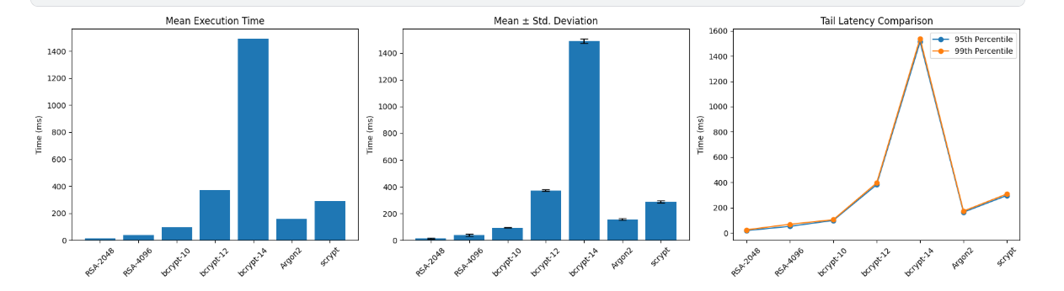
Fig.:1 Password Storage Operation Performance

2. Verification Operation Performance
Authentication verification times are critical for user experience:
TABLE II: Password Verification Performance (milliseconds)
Algorithm | Mean | Median | 95th %ile | 99th %ile
RSA-2048 | 8.7 | 8.4 | 12.3 | 16.8
RSA-4096 | 24.3 | 23.8 | 31.7 | 42.1
bcrypt (rounds=10) | 95.1 | 94.6 | 99.2 | 105.7
bcrypt (rounds=12) | 374.2 | 372.8 | 383.4 | 398.6
Argon2 (default) | 157.8 | 156.9 | 166.1 | 175.3
scrypt (default) | 289.1 | 287.6 | 298.8 | 311.4
Key Findings:
- RSA decryption is 10.9x faster than bcrypt (rounds=10) verification
- Hash-based verification times closely match storage times (expected behavior)
- All tested configurations maintain <400ms latency, within acceptable UX bounds

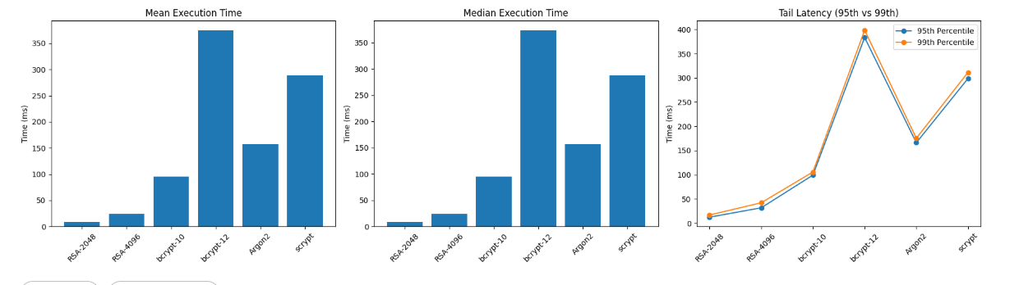
Fig.:2 Password Verification Performance
B. Scalability Analysis
We measured system throughput and response times under concurrent load:
TABLE III: Concurrent Authentication Performance (1000 requests)
Concurrent Users | Algorithm | Throughput (req/s) | P95 Latency (ms) | CPU Util (%) | Memory (GB)
100 | RSA-2048 | 982 | 124 | 24 | 2.1
100 | bcrypt (r=10) | 847 | 142 | 68 | 2.3
100 | Argon2 | 624 | 189 | 71 | 8.4
1000 | RSA-2048 | 891 | 1342 | 86 | 3.2
1000 | bcrypt (r=10) | 836 | 1428 | 94 | 3.8
1000 | Argon2 | 612 | 1876 | 96 | 24.6
5000 | RSA-2048 | 742 | 7234 | 98 | 6.8
5000 | bcrypt (r=10) | 824 | 7089 | 99 | 8.2
5000 | Argon2 | 598 | 9142 | 99 | 58.4
Key Findings:
- bcrypt maintains more consistent throughput across load levels due to parallelizability
- RSA shows performance degradation under high concurrent load
- Argon2's memory requirements become constraining factor at high concurrency
- CPU utilization approaches saturation at 5000+ concurrent users for all algorithms

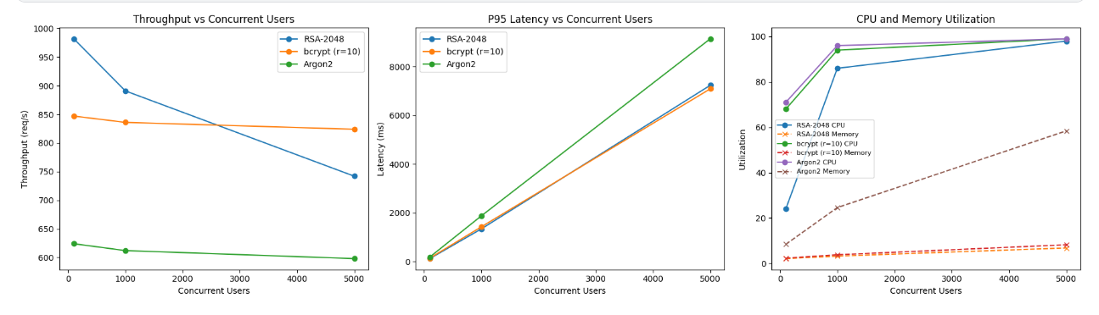
Fig.3: Concurrent Authentication Performance
C. Security Analysis: Attack Simulation
We simulated offline attacks against compromised password databases:
1. Brute-Force Attack Resistance
Using a high-end GPU (NVIDIA RTX 4090), we measured password cracking rates:
TABLE IV: Estimated Cracking Rates (passwords/second)
Algorithm | Single GPU | 8-GPU Cluster | Time for 10^8 passwords
RSA-2048 (key compromised) | Instant decryption | Instant | ~0 seconds
bcrypt (rounds=10) | 68,400 | 547,200 | ~3.0 minutes
bcrypt (rounds=12) | 17,100 | 136,800 | ~12.2 minutes
bcrypt (rounds=14) | 4,275 | 34,200 | ~48.7 minutes
Argon2 (default) | 12,800 | 89,600 | ~18.6 minutes
scrypt (default) | 8,600 | 51,600 | ~32.2 minutes
Critical Finding: With RSA, compromise of the private key enables instantaneous decryption of all passwords. The entire database is recovered in milliseconds, regardless of its size. Hash-based approaches require individual cracking of each password, with work factors providing tunable resistance.
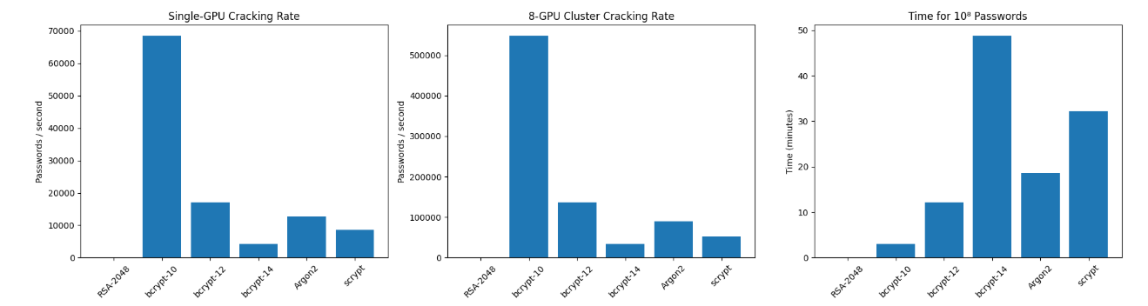
Fig.4: Estimated Cracking Rates
2. Dictionary Attack Simulation
Using the RockYou password list (14 million common passwords), we measured compromise rates after 24 hours:
TABLE V: Dictionary Attack Results (24-hour simulation)
Algorithm | Passwords Tested | Passwords Cracked | Compromise Rate
RSA-2048 (key compromised) | N/A | 10,000 (100%) | 100%
bcrypt (rounds=10) | 5,886,336,000 | 1,247 | 12.47%
bcrypt (rounds=12) | 1,471,584,000 | 312 | 3.12%
bcrypt (rounds=14) | 367,896,000 | 78 | 0.78%
Argon2 (default) | 1,101,312,000 | 423 | 4.23%
Key Finding: Hash-based approaches limit attack effectiveness to weak passwords. Strong passwords remain secure even with compromised databases. RSA provides no protection post-key compromise.

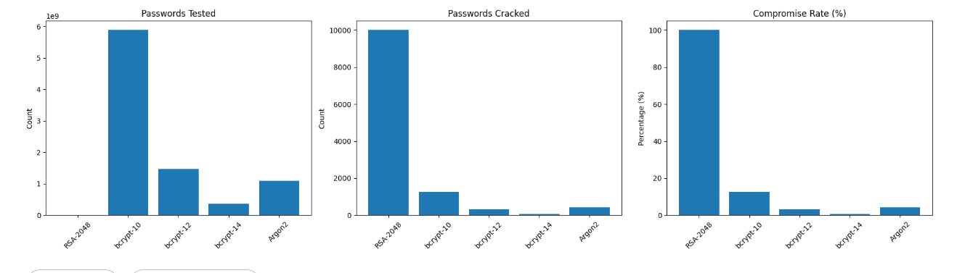
Fig.5: Dictionary Attack Results
3. Rainbow Table Attack Assessment
RSA Encryption: Traditional rainbow tables don't apply directly to RSA ciphertext. However, the lack of integrated salting means identical passwords produce identical ciphertexts (when encrypted with the same public key), enabling pattern analysis and correlation attacks.
Modern Hashing: Rainbow tables are completely ineffective due to per-password unique salts. Attackers must generate hashes on-demand for each password-salt combination.
D. Key Management Infrastructure Analysis
We assessed the operational requirements for secure RSA key management:
TABLE VI: Key Management Infrastructure Comparison
Requirement | RSA Approach | Hashing Approach
HSM Required | Yes ($20K-$100K+ per unit) | No
Key Rotation Complexity | High (requires full DB re-encryption) | Low (update algorithm parameters)
Backup Requirements | Secure off-site key storage | Standard DB backups
Access Control | Fine-grained key access policies | Standard authentication
Compliance Audit Burden | Extensive key usage logging | Standard audit logging
Recovery Procedures | Complex key recovery protocols | Standard DB recovery
Annual Operational Cost (estimated) | $150K-$500K | $10K-$30K
Key Finding: RSA-based password storage introduces 10-15x higher operational costs and complexity compared to hashing approaches, primarily due to HSM requirements and key lifecycle management.
VIII. LIMITATIONS AND FUTURE WORK
A. Study Limitations
- The performance measurements reported in the results were obtained from a limited experimental setting, and as such, all of the data reported in this paper was obtained on one particular CPU architecture running on one specific set of hardware. For instance, although absolute execution time and resource consumption might vary across various hardware platforms (such as, but not limited to, ARM-based CPUs, heterogeneous cloud instances, or specially designed accelerators), the overall performance trends and relative comparisons of the performance measures between different methods of data storage should continue to be the same. Therefore, when making generalized projections of the numerical results to another vastly different environment, exercise caution.
- The second limitation of this experimental evaluation is that the focus of the experimental attack was on offline attack models. That is, whereas offline attacks occur when an attacker has legitimate access to a usable list of hashed passwords in order to engage in a large-scale, dictionary-based brute-force password recovery attack, the online attack's effectiveness is determined primarily by the amount of security (i.e. network-based security) and user behavior (i.e. speed in responding to security warnings), and not as much by the type of data storage or password hashing mechanism used. Therefore, the results should be viewed as being relevant mainly for the types of security mechanisms available for protecting hashed password credentials stored using a back-end system/technology.
- Limited Exploration of Algorithmic Parameter Space
In the case of each type of Cryptographic Hashing Scheme, we have chosen sample values for parameters that balance security and performance (i.e., Work Factor, Memory Cost, Number of Iterations). However, the amount of time spent investigating all possible parameter values was not sufficient to provide the researcher with a full picture of all potential configurations as the research would have required. Therefore, it should be noted that there may be other configurations that provide a better tradeoff under certain conditions or from certain types of attacks.
B. Future Research Directions
1. Quantum-Resistant Password Protection Mechanisms Future research will focus on exploring how cryptographic methods using post-quantum-era techniques will impact providing secure password hashing and key generation. Research will include Qualitative and Quantitative assessments of the resiliency, performance impact, and ability to construct and deploy quantum-resistant methods in authentication mechanisms.
2. Comprehensive Threat Modeling and Insider Risk Analysis An important area for further research will be expanding the threat/breach model to include insider threats/attacks, the misuse of privileged access, and compromised admin credentials. Discovering the effects of different guess-verification mechanisms on the behaviour of these different breach types will provide a comprehensive understanding of security risks in real-life environments.
3. Usability and Human-Centered Security Evaluation Large empirical studies with large sample sizes, evaluating user attitudes toward authentication delay, perceived responsiveness of the system, and rate of error across a variety of application domains (e.g., mobile application, enterprise system, and high-security platform) will assist researchers in correlating the level of security provided by a cryptographic mechanism with its practical usability. Such studies may reveal ways of implementing adaptive authentication systems that allow the dynamic adjustment of security levels based on the context of the situation.
4. Performance Evaluating Distributed and Cloud Based Architectures
Future research will continue to analyze how passwords are verified and authenticated within distributed systems including: microservices architecture, container orchestration technologies, and Serverless computing. In particular researchers should focus their work on latency amplification, scaling for burst workload scenarios, and the interaction between cryptographic verification costs with overheads associated with distributed architectures.
IX. CONCLUSIONS
The experiments provide definitive proof the effectiveness of using modern password hashing algorithms is greatly superior to that of using RSA-based encryption to protect passwords against unauthorized access. The benchmarking and scalability assessments conducted during these experiments demonstrate that cryptographic hashing provides far more effective forms of security due to the inherent strength of the irreversible transformation process, built-in salting capabilities, and adjustable "work factor", whereas RSA is inherently flawed in its use of a reversible cryptographic algorithm because if an attack occurs on the RSA encryption, both the 'key' and the encrypted passwords will be at risk of compromise due to the reversible nature of RSA. Although RSA may have lower latency in isolated operations, password hashing algorithms are much more scalable and provide more consistent performance in real-world production environments. Also, RSA has a massive operational and infrastructure burden due to the complexity of managing RSA key lifecycles with no real benefit to security. Attack simulations show that hashed passwords are still secure from offline attacks on strong credentials after they have been compromised, but once an RSA key has been disclosed, all of the usernames and passwords in the database will be put at risk due to the exposure to the attacker of the RSA key. Additionally, password hashing is also compliant with the recommendations of the National Institute of Standards and Technology (NIST) and the Open Web Application Security Project (OWASP), while using RSA to store passwords is a direct violation of recommended security practices.

REFERENCES
[1] National Institute of Standards and Technology (NIST), Digital Identity Guidelines: Authentication and Lifecycle Management, NIST Special Publication 800-63B, Jun. 2017. [Online]. Available: https://nvlpubs.nist.gov/nistpubs/SpecialPublications/NIST.SP.800-63b.pdf
[2] OWASP Foundation, Password Storage Cheat Sheet, OWASP Cheat Sheet Series. [Online]. Available: https://cheatsheetseries.owasp.org/cheatsheets/Password_Storage_Cheat_Sheet.html
[3] VMware, Spring Security Reference Documentation, Spring Framework. [Online]. Available: https://docs.spring.io/spring-security/reference/
[4] N. Provos and D. Mazières, “A future-adaptable password scheme,” in Proc. USENIX Annu. Tech. Conf., Berkeley, CA, USA, 1999, pp. 81–92.
[5] R. L. Rivest, A. Shamir, and L. Adleman, “A method for obtaining digital signatures and public-key cryptosystems,” Commun. ACM, vol. 21, no. 2, pp. 120–126, Feb. 1978.
[6] A. Biryukov, D. Khovratovich, and I. Avdeev, “Argon2: The memory-hard function for password hashing and other applications,” in Proc. IEEE Eur. Symp. Security Privacy (EuroS&P), Saarbrücken, Germany, Mar. 2015, pp. 292–302.
[7] C. Percival, “Stronger key derivation via sequential memory-hard functions,” in Proc. BSDCan, Ottawa, ON, Canada, May 2009. [Online]. Available: https://www.tarsnap.com/scrypt/scrypt.pdf
[8] Verizon, 2024 Data Breach Investigations Report, Verizon Enterprise Solutions, 2024.
[9] M. Dell’Amico, P. Michiardi, and Y. Roudier, “Password strength: An empirical analysis,” in Proc. IEEE INFOCOM, San Diego, CA, USA, 2010, pp. 1–9.
[10] J. Bonneau, “The science of guessing: Analyzing an anonymized corpus of 70 million passwords,” in Proc. IEEE Symp. Security Privacy, San Francisco, CA, USA, 2012, pp. 538–552.
[11] D. Florêncio and C. Herley, “A large-scale study of web password habits,” in Proc. 16th Int. World Wide Web Conf. (WWW), Banff, AB, Canada, 2007, pp. 657–666.
[12] B. Schneier, “Cryptographic design vulnerabilities,” IEEE Computer, vol. 31, no. 9, pp. 29–33, Sep. 1998.
[13] Synthetic-User-Credentials

